UTILITY CORRIDOR AND ROADWAY RELOCATION

As a result of severe deterioration of the two-level Substructure, the Campus Master Plan calls for its demolition. However, because all primary campus utilities are currently routed through that failing Substructure, a Utilities Master Plan was undertaken by Arup USA Inc. to consider options for rerouting of the utilities necessitated by the demolition. In addition, the Utilities Master Plan also reviewed current utility loads and conditions, evaluated possible alternative sources of energy for the campus, and forecasted future utility loads based upon the anticipated full development build out envisioned in the Campus Master Plan.
Based upon the Utilities Master Plan, a decision was made to provide a campus-wide utility corridor.
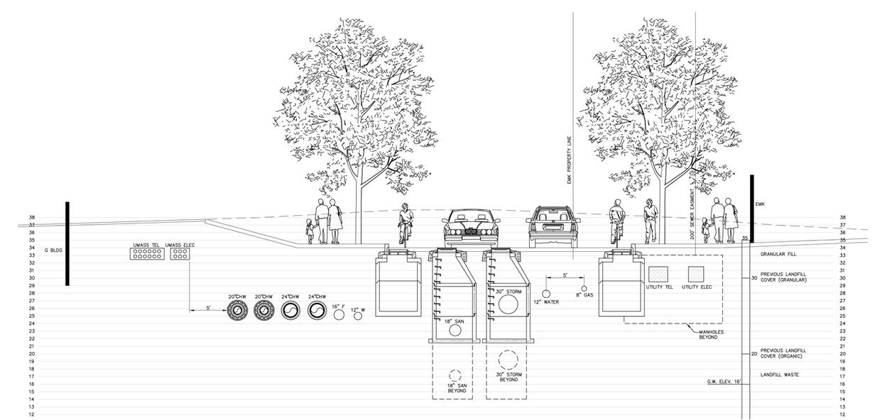
The UMass Building Authority hired BVH Integrated Services Inc. to design the utility corridor with a new two-way roadway system with 11-foot lanes, and to provide various amenities above and beside the two five-foot bike lanes, eight-foot tree lawns and eight-foot sidewalks throughout most of the campus. More than 600 new trees will be planted on campus.
The new utility corridor, comprised of more than 17 miles of new piping and ductbanks, will support future buildings and provide reliable and redundant utility services to the campus. The new roadway and pedestrian system will improve overall traffic circulation and pedestrian connections on campus. The utilities include piping for domestic and fire water, sanitary wastewater, chilled water, heating hot water, and natural gas as well as conduits for electricity, telecommunications and data. A storm water management plan is also part of this project and extensive use of sustainable bio-retention swales to manage storm water run-off will be used.

To ensure the integrity of the utility systems, the existing Central Utility Plant is being upgraded as part of this project.
Relocation of the current University Drive North roadway to the northeast will align it with the end of Mount Vernon Street and provide direct access to the John F. Kennedy Presidential Library and Museum, the Massachusetts Archives and Commonwealth Museum, and the Edward M. Kennedy Institute. In addition the new utility corridor will benefit these UMass Boston neighbors by providing them with more independent utility networks.
In April 2012, Bond Brothers was named the construction manager for this $164 million project.
Some interesting dimensions of this project are included in the chart below:

System | Future/Component | Quantity | Totals
Utilities | Water Piping | Over 26,000 lf
Utilities | Hot Water Piping | Over 15,000 lf
Utilities | Chilled Water Piping | Over 15,000 lf
Utilities | Electrical Ductbanks | Over 10,000 lf
Utilities | Telecommunication Ductbanks | Over 10,000 lf
Utilities | Storm Piping | Over 5,000 lf
Utilities | Gas Piping | Over 4,500 lf
Utilities | Sanitary Piping | Over 3,500 lf | 69,000 lf
Lighting | Pedestrian Light Fixture | Over 200
Lighting | Roadway Light Fixtures | Over 75 | 275
Roadway | Roadway | Over 8,500 lf | 8,500 lf
Curbs | Curbs | Over 15,000 lf | 15,000 lf
Landscaping | Trees | Over 600 | 600
 | Bike Lanes | Over 3 Miles
Bicycles | Bike Parking | Over 200 Spaces
Sidewalks and | Sidewalks and walkways | Over 5.75 Miles
Pedestrian
Walkways

