Taking ALEKS math Assessment?
Location on campus: | Adaptive Computing Lab  Healey Library Upper Level, Rm 31
Days and  Hours: | (Summer) Mon-Fri, 9:00am to 5:00pm;  (Fall/Spring semesters)  Mon-Fri, 7:30am to 9:00pm

Fast Facts on taking ALEKS Math Assessment
 | Technology |  | To complete ALEKS, you will need the appropriate technology: a Windows personal computer, MacOS, or an iPad. You must also have a webcam. Chromebooks will not allow access to ALEKS.
 | Accessing ALEKS |  | Log into WISER→My Academics→Placement Testing→ALEKS Math Place, Prep, Learn. Make sure the pop-up blocker on the internet browser is disabled or the link will not open. Also close out of any other applications before logging into ALEKS.
 | On-Campus Options  Timing  Respondus |  | Students who do not have access to the appropriate technology at home can take the assessment in the Adaptive Computing Lab (ACL - Healey Library Upper Level, room 31.)  The assessment generally takes 2 hours to complete (while some do finish in less time). Please plan start and completion times in accordance with the hours listed above for the ACL. Students in need of testing accommodations should contact ross.center@umb.edu.  Respondus/Lockdown Browser is already installed on the on-campus computers so please do not download the program – simply launch the assessment at the bottom of the screen (see screenshot).  An IT staff member will also be available for assistance in the ACL.
 | Results of Assessment  Additional Attempts for ALEKS |  | The results from the assessment will be available in WISER in about 24-48 hours. Information on placement based on ALEKS results can be found here: On-Track-Guide-to-QR-and-ALEKS.pdf, or enter title of the document into search bar on umb.edu.  If seeking a higher score on ALEKS, there is a 24-hour waiting period between assessment attempts, and use of the learning modules is required (3 hours prior to attempt #2; 5 additional hours prior to attempt #3.) If you have used all three attempts, and/or your ALEKS cohort has expired, please contact assessment.testing@umb.edu for a new code.
 |  | 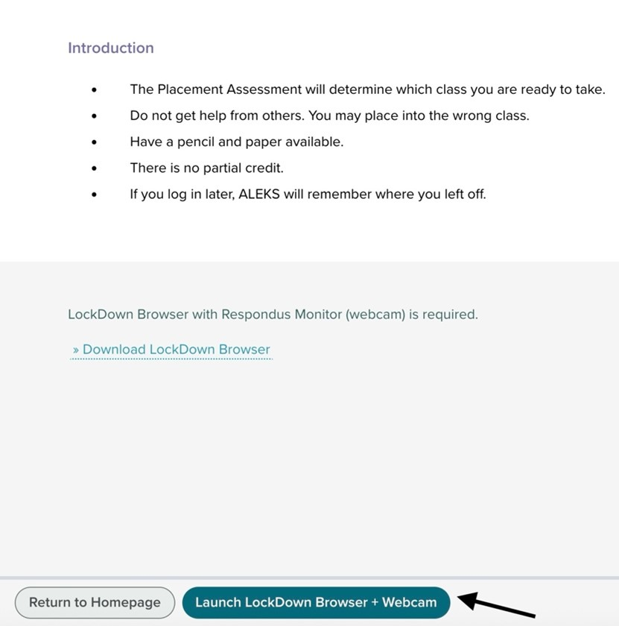

Additional information
If you have questions or concerns, please email assessment.testing@umb.edu!
If you need advising assistance, please contact the advisor listed on your WISER student center page or go to www.umb.edu/advising or email advising@umb.edu to get connected.

